CIED Information System User Guidance

1. Overview

CIED follow-up through telemonitoring offered today by many main CIED vendors, is gradually being adopted in the practice of cardiovascular treatment. The sharing of updated reports and parameter assessment as offered by the data servers and networks connections implemented by many vendors, is helpful for healthcare providers to gain a better understanding of the progress in rehabilitation and the overall effects of medical treatment. Furthermore, emergency alarms and potential problems can be reported and addressed immediately.
In the iCARDEA project, CIED Information Integration System employs standards specifications from ISO/IEEE 11073 (Health Informatics, Point-of-care Medical Device Communication) and HL7v2.x in the context of Integrating the Healthcare Enterprise (IHE) profiles to deliver telemonitoring CIED report data from two different CIED vendors (Medtronic and St. Jude Medical) to the adaptive care planner that implements guideline-driven care plans. And this software component will be practically implemented in the SALK with other interacted software components. This paper shows the basic implementation and operation procedure as well as some notices for the direct user and administer.

2. CIED Data Integration with CIED Vendor data server.

2.1 Medtronic CareLink® platform
Medtronic current system for CIEDs and patient follow-up is based on two approaches:

1. Traditional manual interrogation of the devices in clinic during the patient visit to the electrophysiologist
In this approach, the devices are revised during the consult visits and the device information can be checked by the specialist through the programmer. (The CIED report for the clinical follow-up will be saved in the CIED device and interrogated in the next remote follow-up)

2. Remote monitoring using the CareLink® platform
In this approach, the devices are interrogated automatically or manually. The interrogations may be programmed or can be triggered under demand if the patients or the specialists require it. The information is presented to the professionals through the web based CareLink application or the CSG (Connected System Gateway), Medtronic software application that resides on a secure clinic provided system and enables automatic routing of reports from the CareLink Website to a file system located on a clinic’s local network. Reports are exported from CareLink and stored in file system on clinic’s local network, with a unique filename. Clinic can manually attach them to the patient record or can write custom code to attach them to the patient record.#

Depending on the model of the device implanted, the patient will need to carry out the interrogation manually with the CareLink Monitor Antenna or it will be automatically done wirelessly through the Connexus Wireless Monitor.

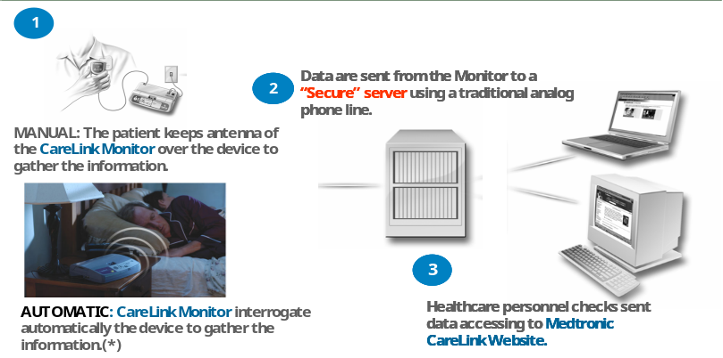
Figure 1. Remote monitoring using the CareLink® platform

Note: CIED Information System is only responsible for the CIED PDF report which is supplied by CareLink® platform.

2.2 St. Jude Medical Merlin.net™

The Merlin.net™ Patient Care Network (PCN) allows integration of essential device data with electronic health records for timely, convenient access to key information that can help optimize clinic resources and streamline patient care. Examples are EHR systems by GEMMS or LUMEDX, or any other system that can process implantable device data delivered as HL7 V2.5 ORU message.

Wireless transmission of industry-standard information from St. Jude Medical pacemakers, ICDs and heart failure devices can be integrated with individual electronic health records (EHR) and is designed to provide a single point of access to pertinent information that can lead to earlier intervention and enhanced patient care.

Disease management functions available in St. Jude Medical wireless ICDs and pacemakers are remotely accessible on Merlin.net PCN: Wireless functionality allows clinics to benefit from efficiencies gained through wireless implants, follow-ups and daily remote monitoring. A complete device and disease diagnostic is possible via the remote monitoring system as the entire diagnostic memory content of the device is transferred and presented in PDF report format.

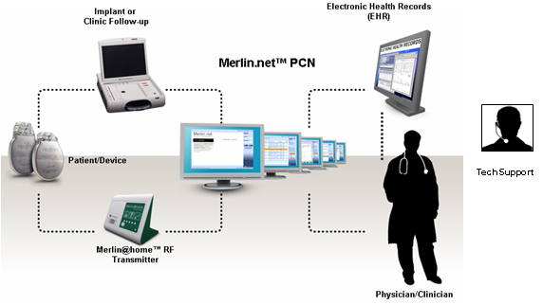

3. CIED Data Integration
Note: Further information about Medtronic and St. Jude Medical CIED system and portals can be found at the iCARDEA Deliverable “D9.1.1 Requirement Specifications and Scenario of the Pilot Application”, available via http://www.srdc.com.tr/projects/icardea/index.php/component/docman/

3.1 CIED data integration by retrieving Medtronic CIED PDF report through CareLink Webpage

In the following the steps needed to download the CIED PDF files from CareLink web are presented.

- Open the Medtronic CareLink Webpage in a browser. Use a browser (e.g. Internet Explorer) to open the Medtronic CareLink Webpage and enter your credentials (e.g. https://europe.medtroniccarelink.net/Clinician/Login/Login.aspx, please refer to your hospital-IT for the correct web link)

- Chose the tab Transmissions and ensure that the View “Active Transmissions” is used. Select the patient and the report to be downloaded by clicking the checkbox on the left.

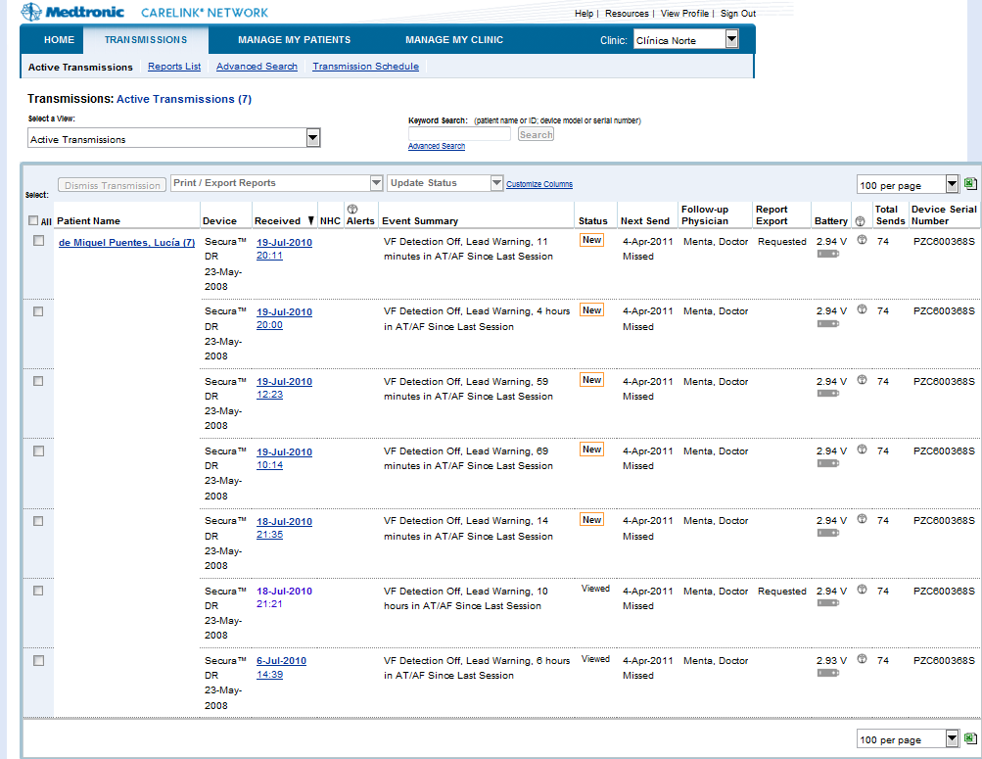

- Click drop down list “Print/Export Report” and select the “Export: Custom Reports” field

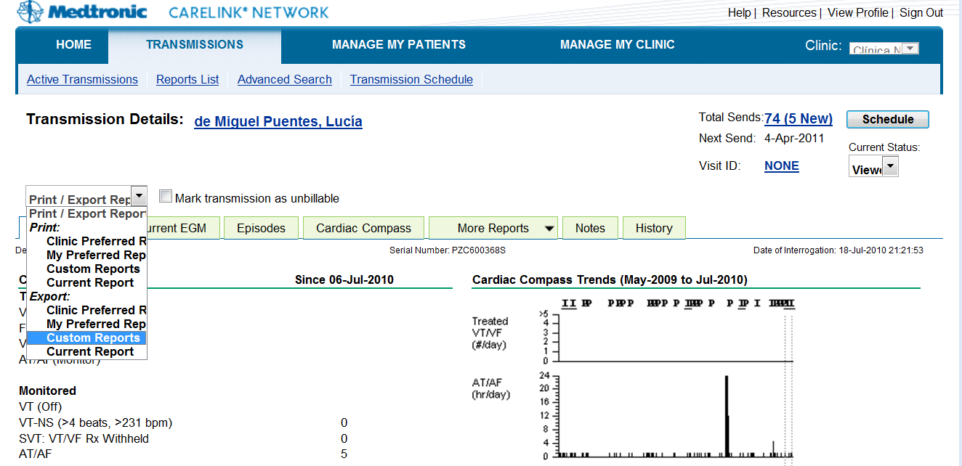

- In the “Request Custom Reports” ensure that the check box “ALL:” is marked for “Select:”. Then click “submit” at the bottom of the webpage.
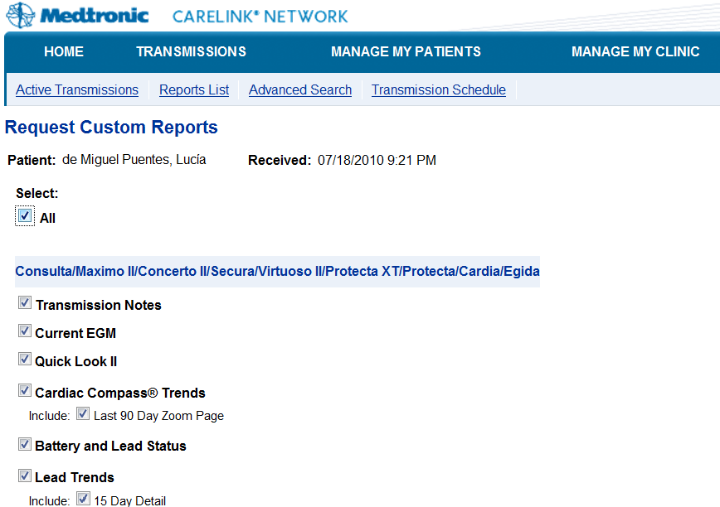

- At the “Transmission” webpage, choose the “Reports List” Click “Available to print”for the reports you want to store and a popup webpage with the CIED Report PDF will appear.

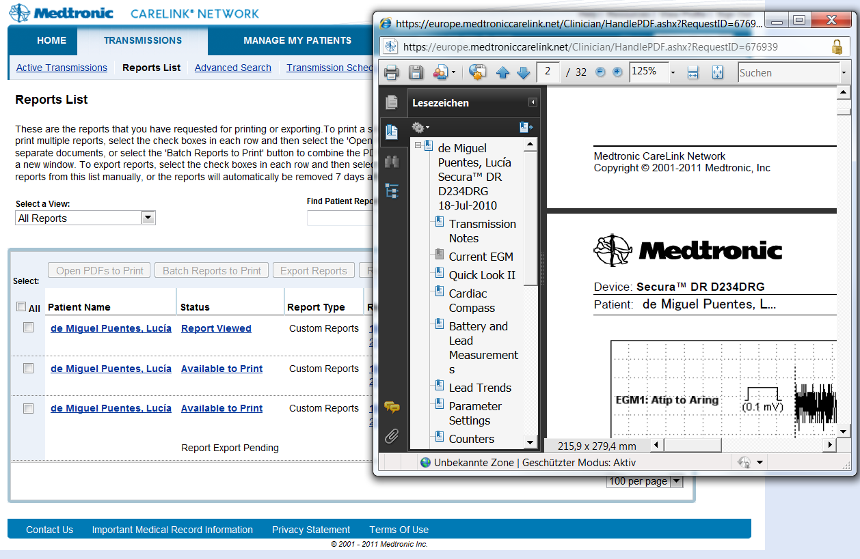

- Save the PDF files with an individual filename in the directory which was given to your hospital IT during the iCARDEA platform installation for Medtronic PDF. (At problems, please mention to the technical partner that the correct directory can be found in the iCARDEA configuration file “AppConfig.properties” indicated by DIRECTORY_MEDTRONIC_ORIGINAL_PDF_REPORT )
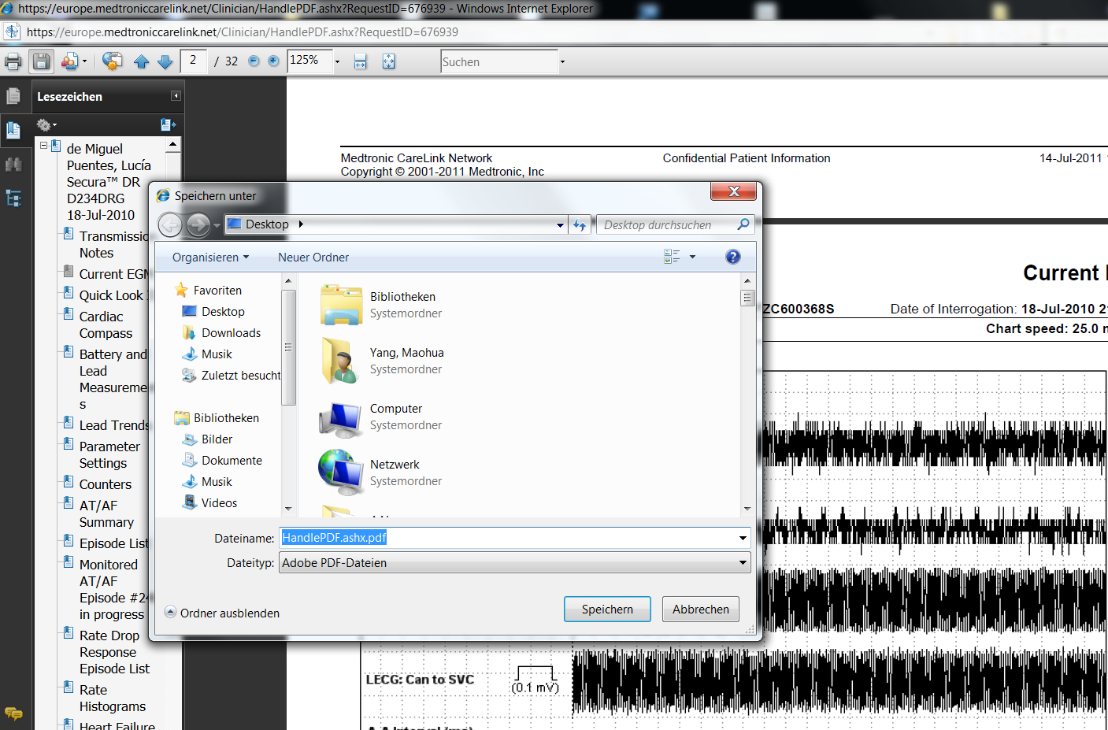

Note: Currently CIED Data Integration Module is only configured for PDF report in English language. Please generate PDF files from CareLink in English form. If you wish to use the German PDF

3.2 CIED data integration with Merlin.net

In the following the steps needed to download the CIED PDF files from Merlin.NET PCN web are presented.

- Open the St. Jude Medical Merlin.Net Webpage in a browser. Use a browser (e.g. Internet Explorer) to open the SJM Merlinn.Net Patient Care Network Webpage and enter your credentials (e.g. https://demo50.merlin.net/ please refer to your hospital-IT for the correct web link)

- If the “Recent Transmissions” is not shown on startup, select a Link indicating to access the patient data or arrhythmia & device management.

- At the “Recent Transmissions” select the reports to be downloaded by marking them on the right side.

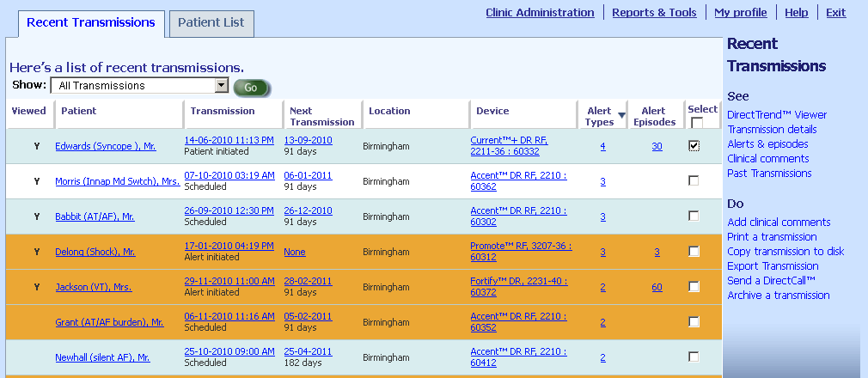
Then click “Copy transmission to disk”

- The following window should appear and ask for the directory to store the data. This is the directory which was given to your hospital IT during the iCARDEA platform installation for SJM Reports. (At problems, please mention to the technical partner that the correct directory can be found in the iCARDEA configuration file “AppConfig.properties” indicated by DIRECTORY_SJM_ORIGINAL_TXT_REPORT)

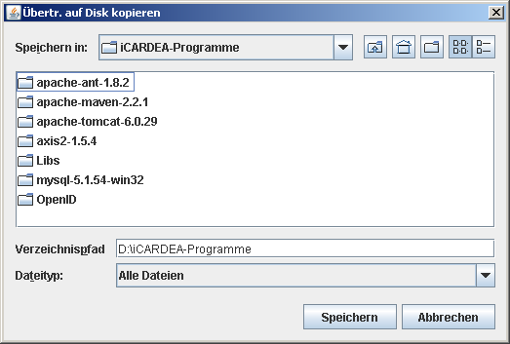

- This creates an folder for the patient and his specific report containing multiple files. This finishes the export of SJM reports. Please do not directly access theses files. To read them, please store them at a different directory.

Note: Currently CIED Data Integration Module is only available for Merlin.Net 5.0 in English language.

4. CIED Information System Configuration

4.1 Configuration HL7 Sending for Adaptive Care Planner.

SEND_TO_CARE_PLANNER=Yes
-Sending to Adaptive Care Planner (Yes/No)

ENCAPSULATED_BASE64_EGM_PDF=NO
-Whether integrate Base64 coded EGM PDF files into HL7 message OBX-Segment (Currently ‘No’)

# LOCAL PARSING defines the format of the file based HL7 Messages
LOCAL_HL7_FILEFORMAT_inXML=No
-Store HL7v2.5 (received from Merlin.Net and parsed by PDF from CareLink) in *.xml or *.hl7 format

ADAPTIVE_CARE_PLANNER_HL7_SERVER=localhost
-The IP address for Adaptive Care Planner

ADAPTIVE_CARE_PLANNER_HL7_PORT=21012
-The port number for Adaptive Care Planner

# definition of the accepted format of the MLLP Server
ADAPTIVE_CARE_PLANNER_HL7_isXML=Yes
-Sending HL7v2.5 to Adaptive Care Planner in *.xml or *.hl7 format.

4.2. Configuration for the HL7 Receiver (Client for Merlin.net) NOT REALISED IN MERLIN NET CURRENTLY.

#The Port for the HL7 message which is transmitted from Merlin.Net
SJM_CLIENT_GENERIC_PORT=21014
-Port number which is specified for receiving HL7 message from Merlin.Net

4.3. Configuration for directory

# The directory for the original CIED PDF files from Medtronic CareLink
DIRECTORY_MEDTRONIC_ORIGINAL_PDF_REPORT=C:\\Test\\Medtronic\\unprocessed\\
-Story the CIED PDF files from CareLink in this directory, and these PDF will be parsed to HL7v2.5 ORU message.

# The directory for the CIED PDF files which has been parsed to HL7 file successfully
DIRECTORY_MEDTRONIC_PROCESSED_PDF_REPORT=C:\\Test\\Medtronic\\processed\\
-After parsing, successfully processed CIED PDF files will be moved into this directory.

# The directory for the CIED PDF files which could not be parsed
DIRECTORY_MEDTRONIC_UNKNOWN_PDF_REPORT=C:\\Test\\Medtronic\\unknown\\
-After parsing, unrecognized PDF files (wrong format, broken file or lacing obligated contents) will be moved into this directory.

# The directory for the EGM PDF files which will be integrated in HL7 OBX-Segment with Base64 Code
DIRECTORY_MEDTRONIC_EXPORTED_EGM=C:\\Test\\Medtronic\\tmp_exported_EGM\\
-During parsing process, required EGM figures will be abstracted and reconverted into a new PDF files and stored in this directory for Base64 coded integration.

# The input directory for HL7 Message which will be processed by the PIX Module
# Currently the Medtronic PDF file parsed and transformed to HL7 message
# and the received St. Jude Medical HL7 message will be stored here
DIRECTORY_ORIGINAL_HL7_MESSAGE=C:\\Test\\hl72pix\\
-HL7 parsed by CareLink PDF files and received from Merlin.Net will be stored in this directory for PIX integration processing.

# The output directory for HL7 message after PIX integration processing
# Currently the HL7 Sender module uses this as input dir. for the outgoing transmission
DIRECTORY_PIX_HL7_MESSAGE=C:\\Test\\hl7withpix\\
-After PIX integration processing, new HL7 with Patient Identify will be stored in this directory for transmission to Adaptive Care Planner.

# The directory for HL7 messages which have been successfully transmitted through MLLP and TCP
DIRECTORY_HL7_TRANSMITTED=C:\\Test\\hl7_transmitted\\
-Successful transmitted HL7 message wil be stored in this directory.

Appendix A: Flow chart for the data processing

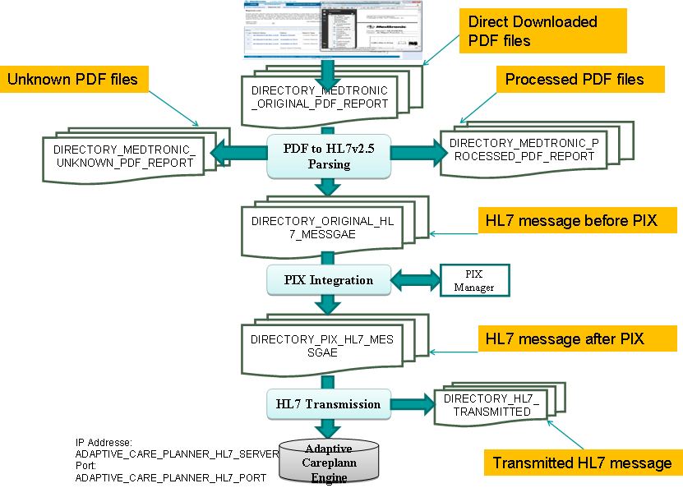

All parameters have been defined in configuration file: Appconfig.properity. Please reconfigure all parameters conform to own practical implementation.

1a. PDF report from Medtronic will be downloaded through Webpage manually into directory: DIRECTORY_MEDTRONIC_ORIGINAL_PDF_REPORT

Note: If PDF files could not be downloades by CareLink webpage directly because of firewall or any other reasons, please get PDF files outside the firewall and copy past received PDF files into the directory configured through DIRECTORY_MEDTRONIC_ORIGINAL_PDF_REPORT

2a. PDF report will be parsed and generated HL7 messages will be stored in directory: DIRECTORY_ORIGINAL_HL7_MESSAGE. The successfully parsed PDF files will be moved into directory DIRECTORY_MEDTRONIC_PROCESSED_PDF_REPORT. And the unrecognized PDF files will be moved to directory DIRECTORY_MEDTRONIC_UNKNOWN_PDF_REPORT.

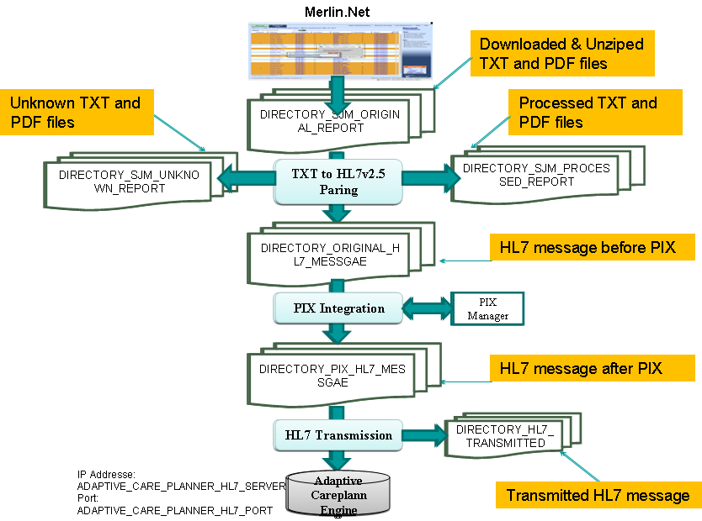
1b. Files from SJM will be downloaded through Webpage manually into directory: DIRECTORY_SJM_ORIGINAL_REPORT

Note: If files could not be downloades by webpage directly because of firewall or any other reasons, please get files outside the firewall and copy past received PDF files into the directory configured through DIRECTORY DIRECTORY_SJM_ORIGINAL_REPORT

2b. Files will be parsed and generated HL7 messages will be stored in directory: DIRECTORY_ORIGINAL_HL7_MESSAGE. The successfully parsed PDF files will be moved into directory DIRECTORY_SJM_PROCESSED_REPORT. And the unrecognized PDF files will be moved to directory DIRECTORY_SJM_UNKNOWN_REPORT.

3. The next steps are the same for Medtronic and SJM, not depending from the data source.

4. HL7 files parsed by PDF from CareLink and from Merlin.Net will be processed through PIX Integration. And the processed HL7 files integrated with Patient identify will be stored in directory: DIRECTORY_PIX_HL7_MESSAGE

5. All HL7 files with patient identify will be transmitted to Adaptive Care Planner through IP address: ADAPTIVE_CARE_PLANNER_HL7_SERVER and port number ADAPTIVE_CARE_PLANNER_HL7_PORT in format ADAPTIVE_CARE_PLANNER_HL7_isXML

6. Successfully transmitted HL7 files will be moved into directory DIRECTORY_HL7_TRANSMITTED

Appendix B. Tips for the user

The notes for the user and administer in SALK
1. Please use Internet Explorer Web Browser to retrieve CIED PDF from CareLink and Merlin.Net and make sure no pop up blocker is in place.

2. Currently all PDF report in SALK will be shown only in English form.

Appendix: C Appconfig.properity

####################################################
# #
# D I R E C T O R Y S C A N N E R - S E T U P #
# #
####################################################
# The unit to be used for the scan interval time.
# This can be 'seconds' (default), 'minutes' or 'hours'. The case is ignored.
DIRECTORYSCANNER_SCAN_INTERVAL_UNIT=seconds

# The directory scan interval time (pause time between scans).
DIRECTORYSCANNER_SCAN_INTERVAL_TIME=10

# The list of directories to scan. Each directory entry is separated by a '#' character from the next entry.

# The directory for the original CIED PDF files from Medtronic CareLink
DIRECTORY_MEDTRONIC_ORIGINAL_PDF_REPORT=C:\\Dokumente und Einstellungen\\dvxxx\\Eigene Dateien\\medtronic_pdf\\

# The directory for the CIED PDF files which has been parsed to HL7 file successfully
DIRECTORY_MEDTRONIC_PROCESSED_PDF_REPORT=d:\\OFFIS\\data\\Medtronic\\processed\\

# The directory for the CIED PDF files which could not be parsed
DIRECTORY_MEDTRONIC_UNKNOWN_PDF_REPORT=d:\\OFFIS\\data\\Medtronic\\unknown\\

# The directory for the EGM PDF files which will be integrated in HL7 OBX-Segment with Base64 Code
DIRECTORY_MEDTRONIC_EXPORTED_EGM=d:\\OFFIS\\data\\Medtronic\\tmp_exported_EGM\\

# The input directory for HL7 Message which will be processed by the PIX Module
# Currently the Medtronic PDF file parsed and transformed to HL7 message
# and the received St. Jude Medical HL7 message will be stored here
DIRECTORY_ORIGINAL_HL7_MESSAGE=d:\\OFFIS\\data\\hl72pix\\

# The output directory for HL7 message after PIX integration processing
# Currently the HL7 Sender module uses this as input dir. for the outgoing transmission
DIRECTORY_PIX_HL7_MESSAGE=d:\\OFFIS\\data\\hl7withpix\\

# The directory for HL7 messages which have been successfully transmitted through MLLP and TCP
DIRECTORY_HL7_TRANSMITTED=d:\\OFFIS\\data\\hl7_transmitted\\

# The directory for received HL7 messages (only for testing)
DIRECTORY_HL7_RECEIVED=d:\\OFFIS\\data\\hl7_careplanner_received\\

####################################################
# #
# P D F - P A R S E R - S E T U P #
# #
####################################################
# The language setting for the PDFParser. It identifies the specialized
# property file read by the parser.
# This is the two letter ISO 639-1 language code e.g. 'en' (default), 'de', etc. The case is ignored.
PDFPARSER_LANGUAGE_SETTING=en

PDFPARSER_SUPPORTED_ICD_TYPE=Consulta|Maximo II|Concerto II|Secura|Virtuoso II|Protecta XT|Protecta|Concerto|Reveal
####################################################
# #
# A D A P T I V E C A R E P L A N N E R #
# S E T U P #
# #
####################################################

# if we say no, we start an local server to receive the messages,
# for demo and testing purpose
SEND_TO_CAREPLANNER=No

ENCAPSULATED_BASE64_EGM_PDF=NO
#Encapsulated_Base64_EGM_PDF_File=No

# LOCAL PARSING defines the format of the file based HL7 Messages
LOCAL_HL7_FILEFORMAT_inXML=No
ADAPTIVE_CARE_PLANNER_HL7_SERVER=localhost
ADAPTIVE_CARE_PLANNER_HL7_PORT=21012

# definition of the accepted format of the MLLP Server
ADAPTIVE_CARE_PLANNER_HL7_isXML=Yes

####################################################
# #
# HL7 Receiver #
# S E T U P #
# #
####################################################
HL7_RECEIVER_PIPE_PORT=21011
HL7_RECEIVER_XML_PORT=21012
HL7_RECEIVER_GENERIC_PORT=21013

SJM_CLIENT_GENERIC_PORT=21014

####################################################
# #
# PIX Manager #
# S E T U P #
# #
####################################################
PIX_MANAGER=localhost
PIX_PORT=2575

